How many applications?

The Playing Queensland Fund is a rolling fund that accepts applications year-round. This fact sheet represents data from applications that were received in the 2014 calendar year.

59 applications for the Playing Queensland Fund were received in 2014. Of these applications, 41 (69%) were successful.

How much?

$3.075 million was requested from the Playing Queensland Fund by 59 applicants in 2014. The average funding request was $52 119. $2.152 million was invested in 41 applications.

The amount invested per successful application in 2014 varied from $2000 – $286 122 depending on the nature of the program and scale of the tour with an average of $52 493 awarded.

Successful applicants received between 42% - 100% of their initial funding request with 83% of all successful applicants receiving their entire request.

Where were applications from?

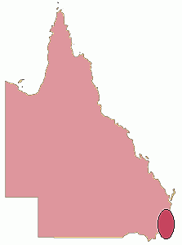

34 applications were from Brisbane City LGA. $1 880 206 was invested in 27 of these applications.

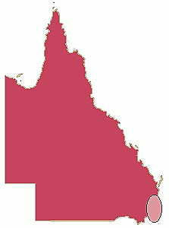

14 applications were from regional Queensland. $109 939 was invested in 8 of these applications.

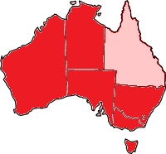Who applied?

11 applications were from interstate, $162 081 was invested in 6 of these applications.

Organisations made up the majority of applicants (76%), followed by individuals (19%) and groups (5%).

Organisations also represented the largest proportion of successful applicants (78%), followed by individuals (17%) and groups (5%).

The majority of applications were proposed for theatre (31) or music (22) tours followed by community engagement (2), dance (2), visual arts (1) and writing (1).

Theatre had the highest number of successful applications (24) followed by music (14), dance (2) and visual arts (1). There were no successful community engagement or writing applications.

Projects aimed at specific community groups

Applicants indicated their project was aimed at one or more of the following specific community groups. The groups most frequently targeted by applicants were people in regional areas (all 59 applications*) and young people (30 applications) or children (21 applications).

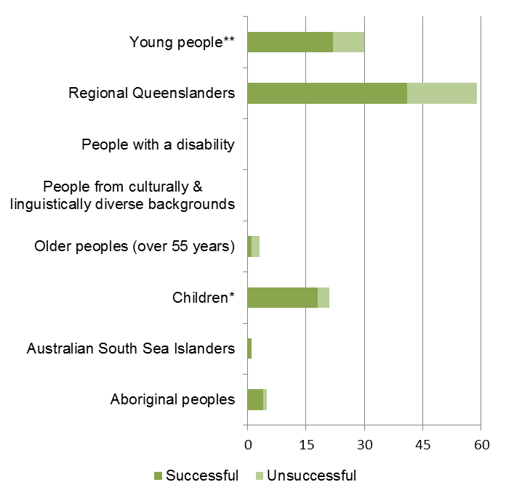

Where were tours proposed?

The map below shows the location of funded tours:

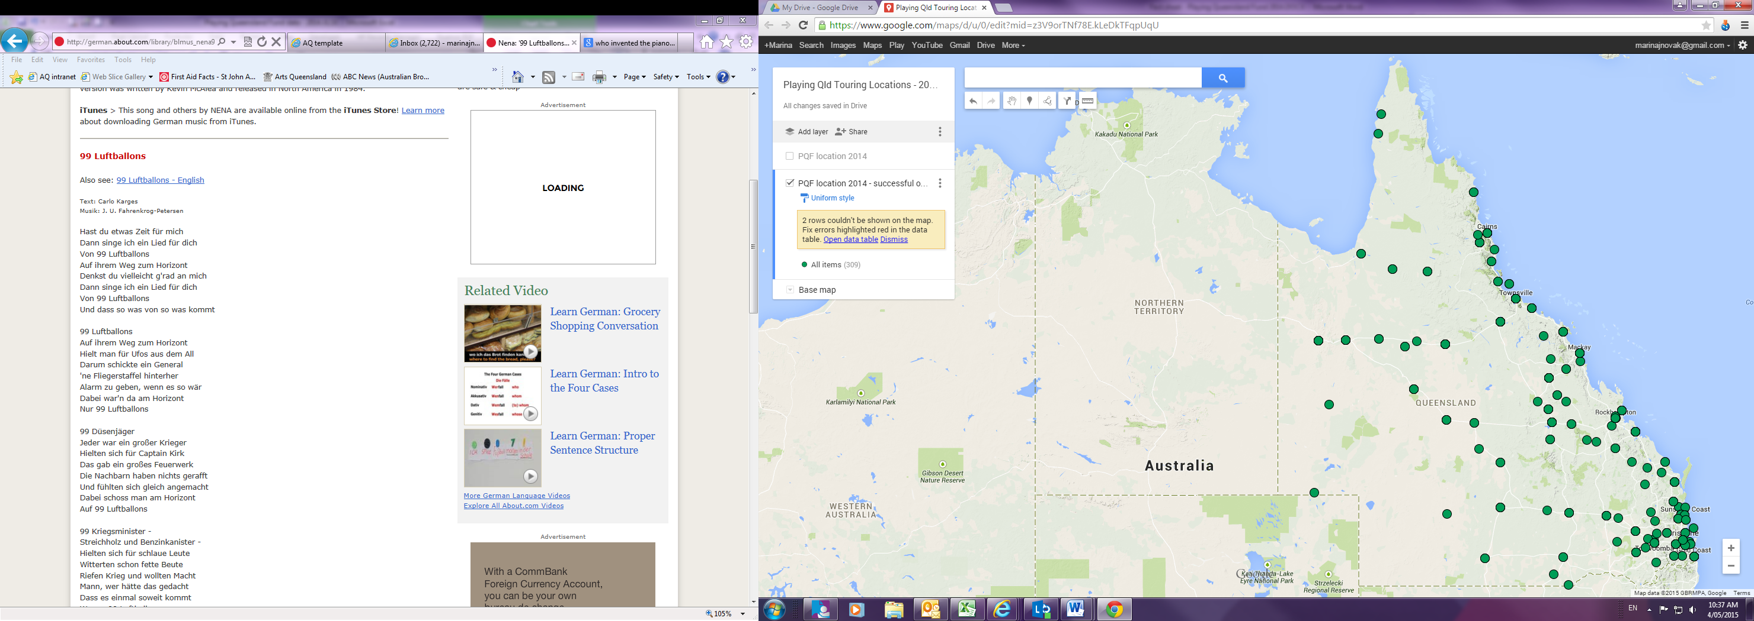

Links:

[Playing Queensland Fund](https://www.qld.gov.au/recreation/arts/funding/organisations/playing/) – Guidelines, application information and application forms  
[Funding Recipients](http://www.arts.qld.gov.au/funding/funds-outcomes.html) – Successful recipient details and general feedback  
[Open Data](https://data.qld.gov.au/) – AQ’s Arts and cultural investment data